Academic Year: 2025-2026 Term: Even (Jan. 2026 – Jun. 2026)
Class / Branch: SE – AIML Semester: IV
Course: Web Programming Lab. (AI4VS_LR4)
Date of Assignment: / /2026 Date of Submission: / /2026

Pre-Lab Exercises for Experiment-10
Exercise 1: Understanding Node.js Environment  Task:  - Install Node.js.  - Verify installation using:  - node -v  - npm -v  - Create a folder named practice-node.  - Initialize npm inside it.  - Identify the purpose of and explain :  - package.json  - node_modules  - dependencies | 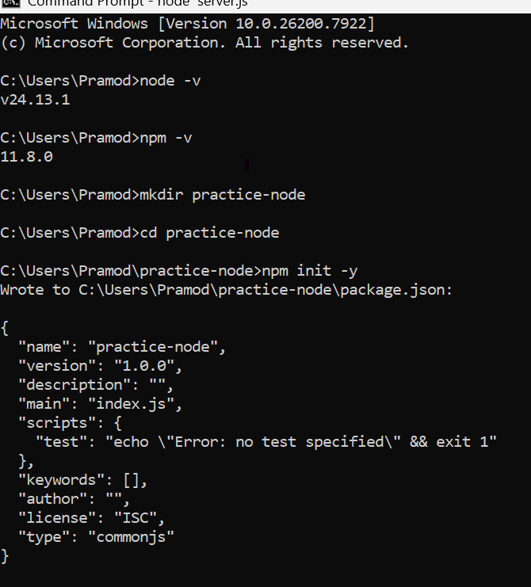

Exercise 2: Create a Basic Node Server (Without Express)
Task:

- Create a simple HTTP server using Node’s built-in http module.
- Make it respond with:
  - “This is a Node server”
- Run the server.
- Access it in the browser using localhost.

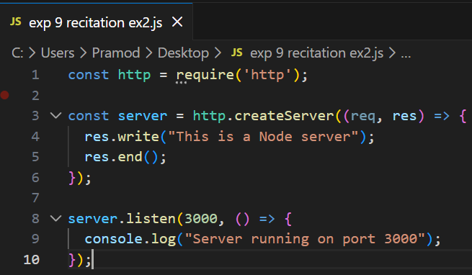  ✅ What happens when you refresh the browser?  When you refresh the browser:  - The browser sends a new HTTP request to the server.  - The server processes the request again.  - The same response (“This is a Node server”) is displayed again.  - The server does not stop; it keeps running and responding to requests.  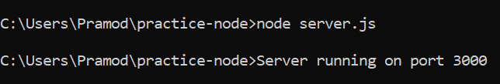 |   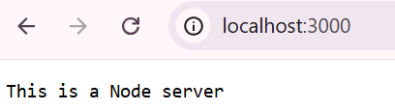  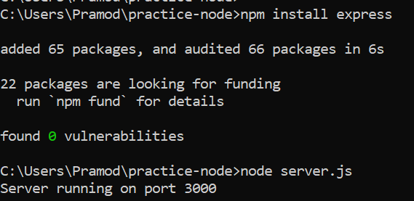  ✅ What happens if you change the port?  If you change the port number in the server code (for example from 3000 to 4000):  - The server starts running on the new port.  - You must access the server using the new port (e.g., http://localhost:4000).  If you try the old port (3000), the browser will show an error like Cannot connect or This site can’t be reached.

Exercise 3: Install and Explore Express

Task:  - Create a new folder express-practice.  - Initialize npm.  - Install Express.  - Observe and explain  - Changes in package.json  - Creation of node_modules  - Write down:  ✅ What is Express?  Express.js is a lightweight and flexible web application framework for Node.js.  It provides a simple way to build web servers and APIs using JavaScript.  Express helps in handling routes, requests, responses, and middleware easily. | 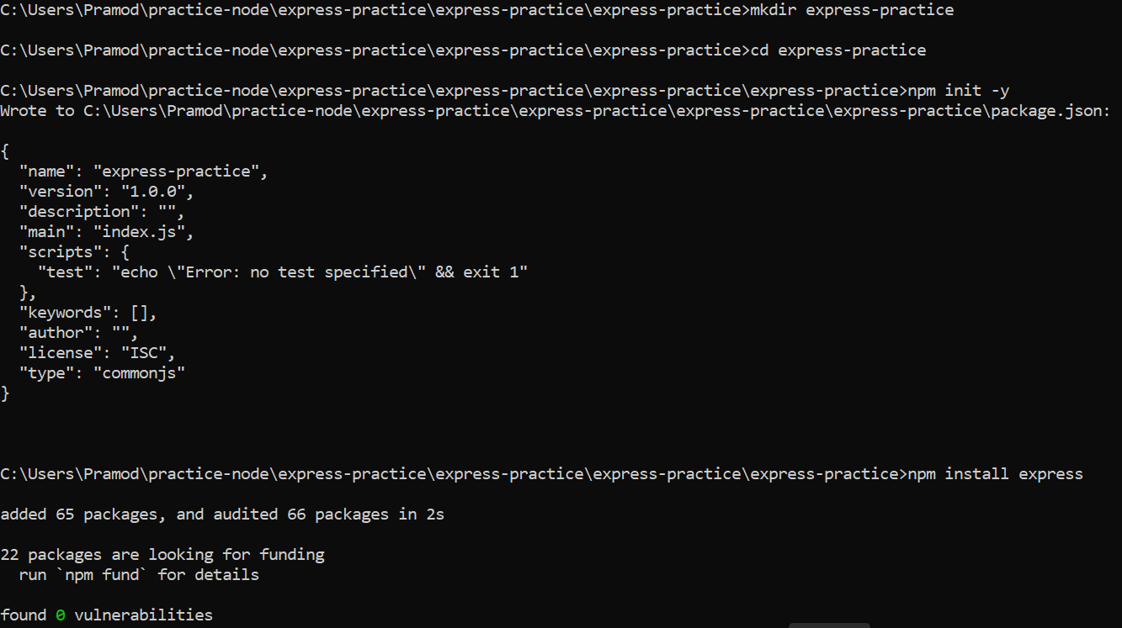  ✅ Why is it used?  Express is used because:  - It simplifies server-side coding.  - It makes routing easy (like /home, /contact).  - It supports middleware for request handling.  - It is fast and lightweight.  - It is widely used for building REST APIs and web applications.
Exercise 4: Create Simple Routes
Task :  - Create an Express server.  - Create the following routes:  - / → Send text response  - /contact → Send text response  - /help → Send text response  - Test each route in browser.  1. What happens if you type a route that is not defined?  If a route is not defined in the Express server, the browser shows an error message such as “Cannot GET /route” or 404 Page Not Found. This happens because the server does not have any handler for that specific URL path.  2. How does Express differentiate routes?  Express differentiates routes based on the URL path and HTTP method (such as GET, POST, PUT, DELETE). When a request comes to the server, Express matches the request URL with the routes defined using functions like app.get(). If the path matches, Express executes the corresponding route handler. | 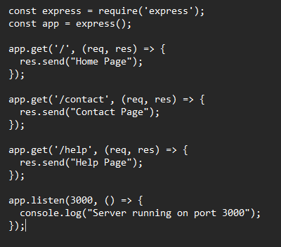      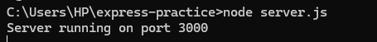

Exercise 5: Return JSON Data
Task :  - Create a route /api/user.  - Return JSON data with:  - name  - age  - course  - Test using:  - Browser  - Postman  1. What is the format of JSON?  JSON (JavaScript Object Notation) is a lightweight data format used for storing and exchanging data between a server and a client. It represents data using key–value pairs and is written inside curly braces { }. The keys are strings and the values can be numbers, strings, arrays, objects, or boolean values.  2. How is JSON different from plain text?  JSON is a structured data format that organizes data using key–value pairs, making it easy for programs to read and process. Plain text, on the other hand, is simply unformatted text without any specific structure. JSON is commonly used for data exchange in web applications, while plain text is mainly used for simple messages or documents. | 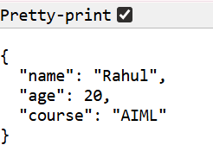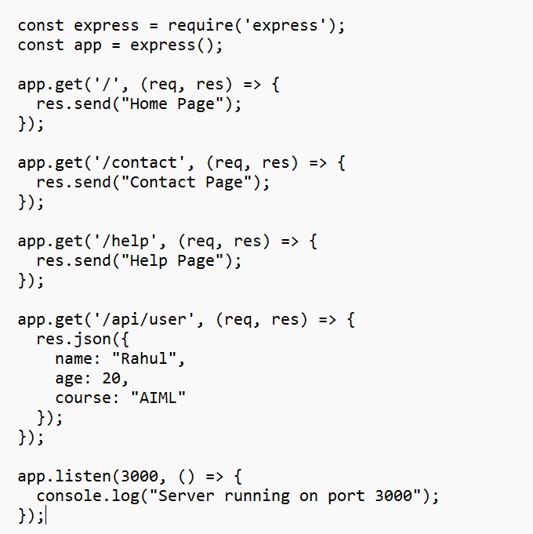

Exercise 6: Middleware Practice  Task:  - Create middleware that logs the following details for every request:  - Request Method  - Request URL  - Attach the to application.  - Access different routes.  1. Does middleware run for every request?  Yes, middleware runs for every request made to the server if it is attached using app.use(). It processes each incoming request before it reaches the route handler.  2. When does it execute?  Middleware executes after the server receives the request and before the route handler sends the response to the client. It works between the request and response cycle. | 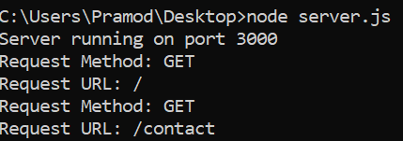  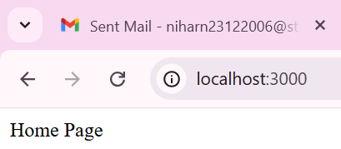  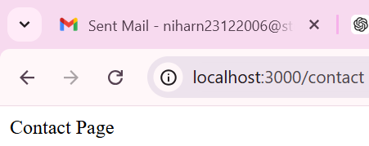

Exercise 7: nodemon Practice
Task:  - Install nodemon.  - Run your Express server using nodemon.  - Modify your server file.  - Observe behavior.  What is the difference between running with node and nodemon?  Running a program with node starts the server once and requires manual restarting whenever code changes are made. Nodemon automatically restarts the server whenever it detects changes in the project files.  Why is nodemon useful during development?  Nodemon is useful because it automatically restarts the server after code changes, saving time and making development faster and more efficient. | 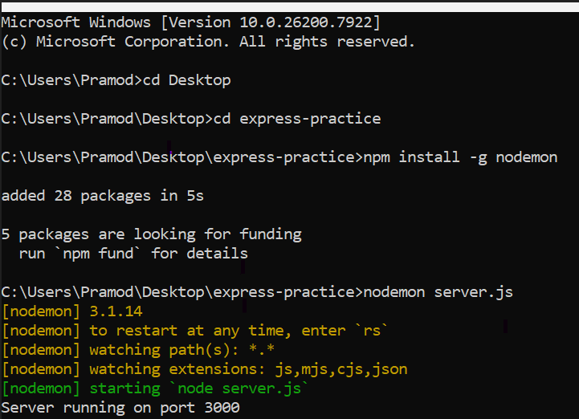  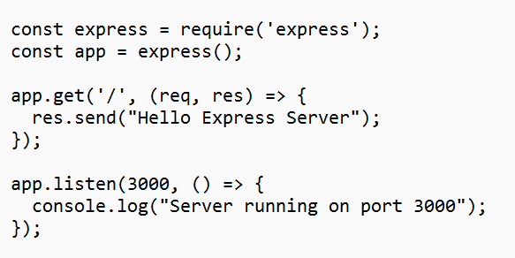  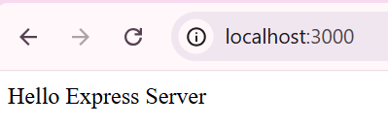

Exercise 8: 404 Handling
Task:  - Create a handler for undefined routes.  - Return:  - “Page Not Found”  Test with an invalid URL.  Question  Why is 404 handling important in backend development?  404 handling is important because it informs the user when a requested route or page does not exist. It helps manage errors properly and improves the overall user experience by giving a clear response from the server. | 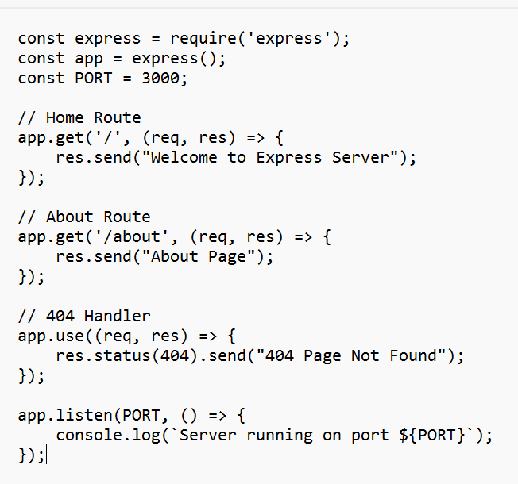  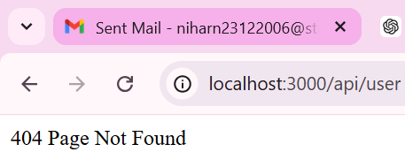

Exercise 9: Request–Response Analysis
After completing all exercises, write:  - Step-by-step explanation of what happens when:  - A user types localhost:3000/ in browser.  2. Explanation  What is a Request?  A request is a message sent by the client (browser) to the server asking for data or a service.  What is a Response?  A response is the reply sent by the server back to the client containing the requested data or result.  Where does Middleware Execute?  Middleware executes between the request and the response, before the final route handler sends the response. | 